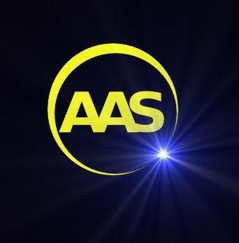
Privacy notice for Aberdeen Astronomical Society

Aberdeen Astronomical Society takes your privacy seriously. We are a “controller” of the personal information that you provide to us and this privacy notice sets out how, why and for how long we will use your personal data, as well as who it is shared with. It also explains your legal rights as a data subject and how to exercise them.

What we need from you

When you register as a member of Aberdeen Astronomical Society or renew your membership we ask you for the following personal information:

- Contact details – name, address, email and phone number.

If you do not provide us with all of the personal information that we need this may affect our ability to offer you our membership services and benefits.

Why we need your personal information – legitimate purposes

We process our members’ personal information in pursuit of our legitimate interests to:

- Provide you with news and updates about the activity of the society, opportunities to get involved in club meetings, observing, general meetings or other events.
- Invite you to join our discussion group aberdeenastro@groups.io
- Raise awareness of the club’s activities by capturing photos and videos. We will use this for promotion, education and development purposes.
- Respond to and investigate your questions, comments, support needs, complaints, concerns or allegations.

Who we share your personal information with

We do not share your personal information with anyone.

How we protect your personal information

Your personal information is accessed by our committee only for the purposes set out above. Membership forms are stored by our secretary in a locked safe and a secure, password protected copy of the membership database is stored online at aberdeenastro@groups.io

How long we keep your personal information

We only keep your personal information for as long as necessary to provide you with membership services. Unless you ask us not to, we will review and delete your personal information where you have not renewed your membership with us for 3 years.

You have a right to:

- Change your communication preferences or restrict the processing of your personal data for specific purposes.
- Request that we correct your personal data if you believe it is inaccurate or incomplete.
- Request that we delete your personal information.
- Access the personal data that we hold about you through a “subject access request”.

You can contact us at aas@aberdeenastro.org.uk

If you are dissatisfied, you have a right to raise a complaint with the Information Commissioner’s Office at www.ico.org.uk

